Low-Code Application Development using Zoho Creator

EXPERIMENT – 2

Title:
Setting up a Zoho Creator account and exploring the platform architecture and interface.
ROLL NO: 240701311
NAME: Mithil S

Aim
To create and configure a Zoho Creator account, build a sample application, and explore the platform architecture and user interface. The experiment also aims to understand the basic components of Zoho Creator, including Forms, Reports, Dashboards, Pages, Workflows, and the Develop, Deploy, and Manage modules used in low-code application development.

2. Setting Up Zoho Creator

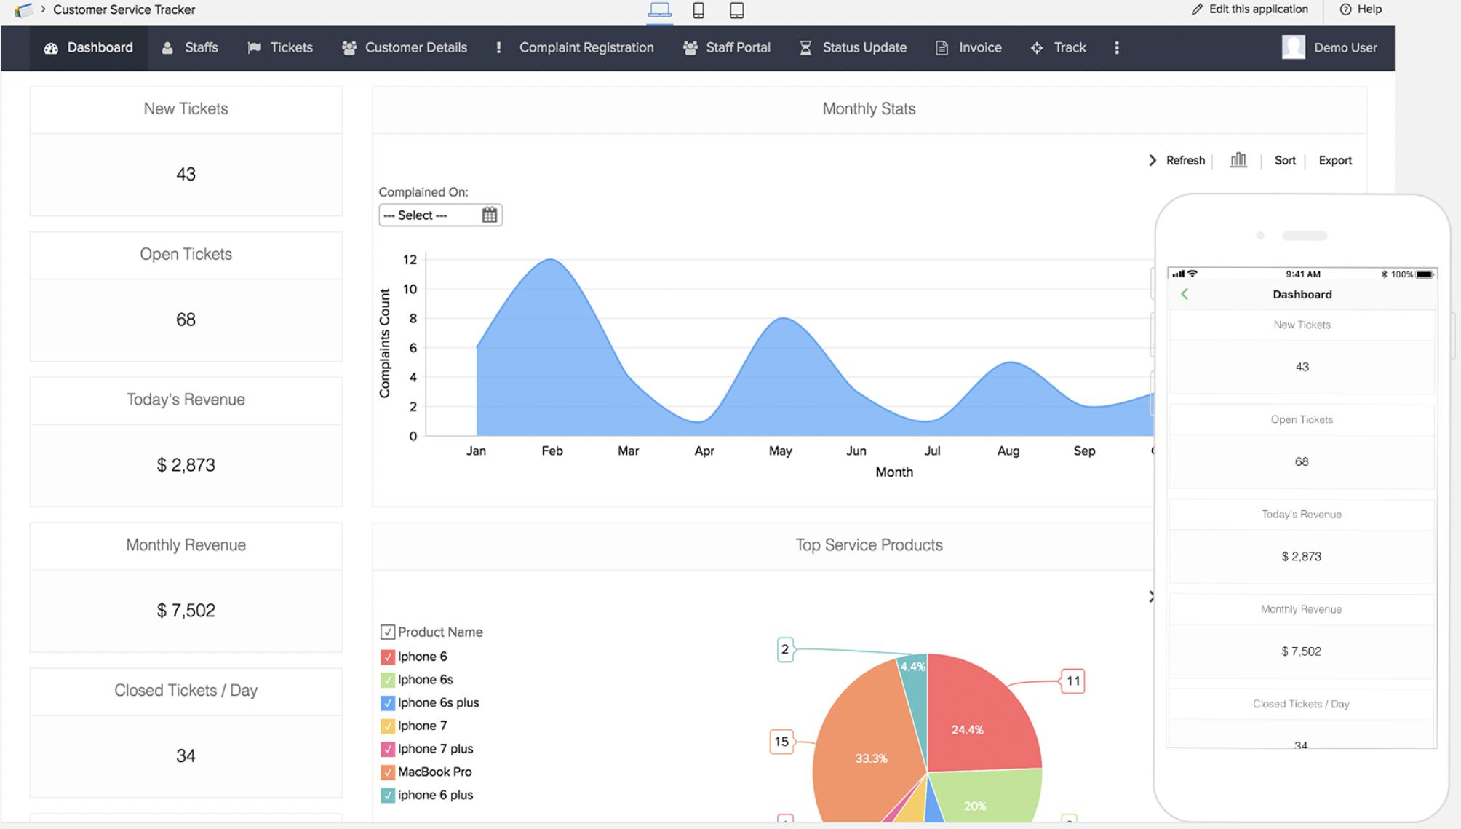

Creating a Zoho Creator Account
Zoho Creator is a cloud-based low-code application development platform that enables users to build custom business applications with minimal coding knowledge. A Zoho Creator account was created by registering with an email address and verifying the account. After successful login, the Zoho Creator home page displayed options to create applications, manage projects, and access various development tools.
The platform provides an easy drag-and-drop interface, making application development faster and more efficient for both beginners and professionals.

(i) Create a Sample Application
A sample application was created using the Demo Application available during sign-up. The application was used to understand the basic structure of a Zoho Creator project.
The sample application contained:
- Forms for entering data
- Reports for displaying records
- Dashboard for data visualization
- Navigation pages
- Basic workflows
This helped in understanding how different components are connected to develop a complete low-code application.
(Paste Screenshot – Sample Application Here)

(ii) Creating Forms, Reports and Dashboard

Form
Forms are used to collect and store user information. Different field types such as Single Line, Number, Email, Date, Dropdown, and Phone Number can be added using drag-and-drop components. Forms act as the primary interface for entering application data.
(Paste Screenshot – Form Here)

Report
Reports automatically display the records entered through forms. They provide options to search, sort, filter, edit, and delete data. Reports help users organize and analyze information efficiently.
(Paste Screenshot – Report Here)

Dashboard
Dashboards present the application data visually using charts, graphs, KPIs, and widgets. Multiple reports can be combined into a single dashboard to monitor business performance and important statistics in real time.
(Paste Screenshot – Dashboard Here)

3. Exploring the Platform Architecture and Interface

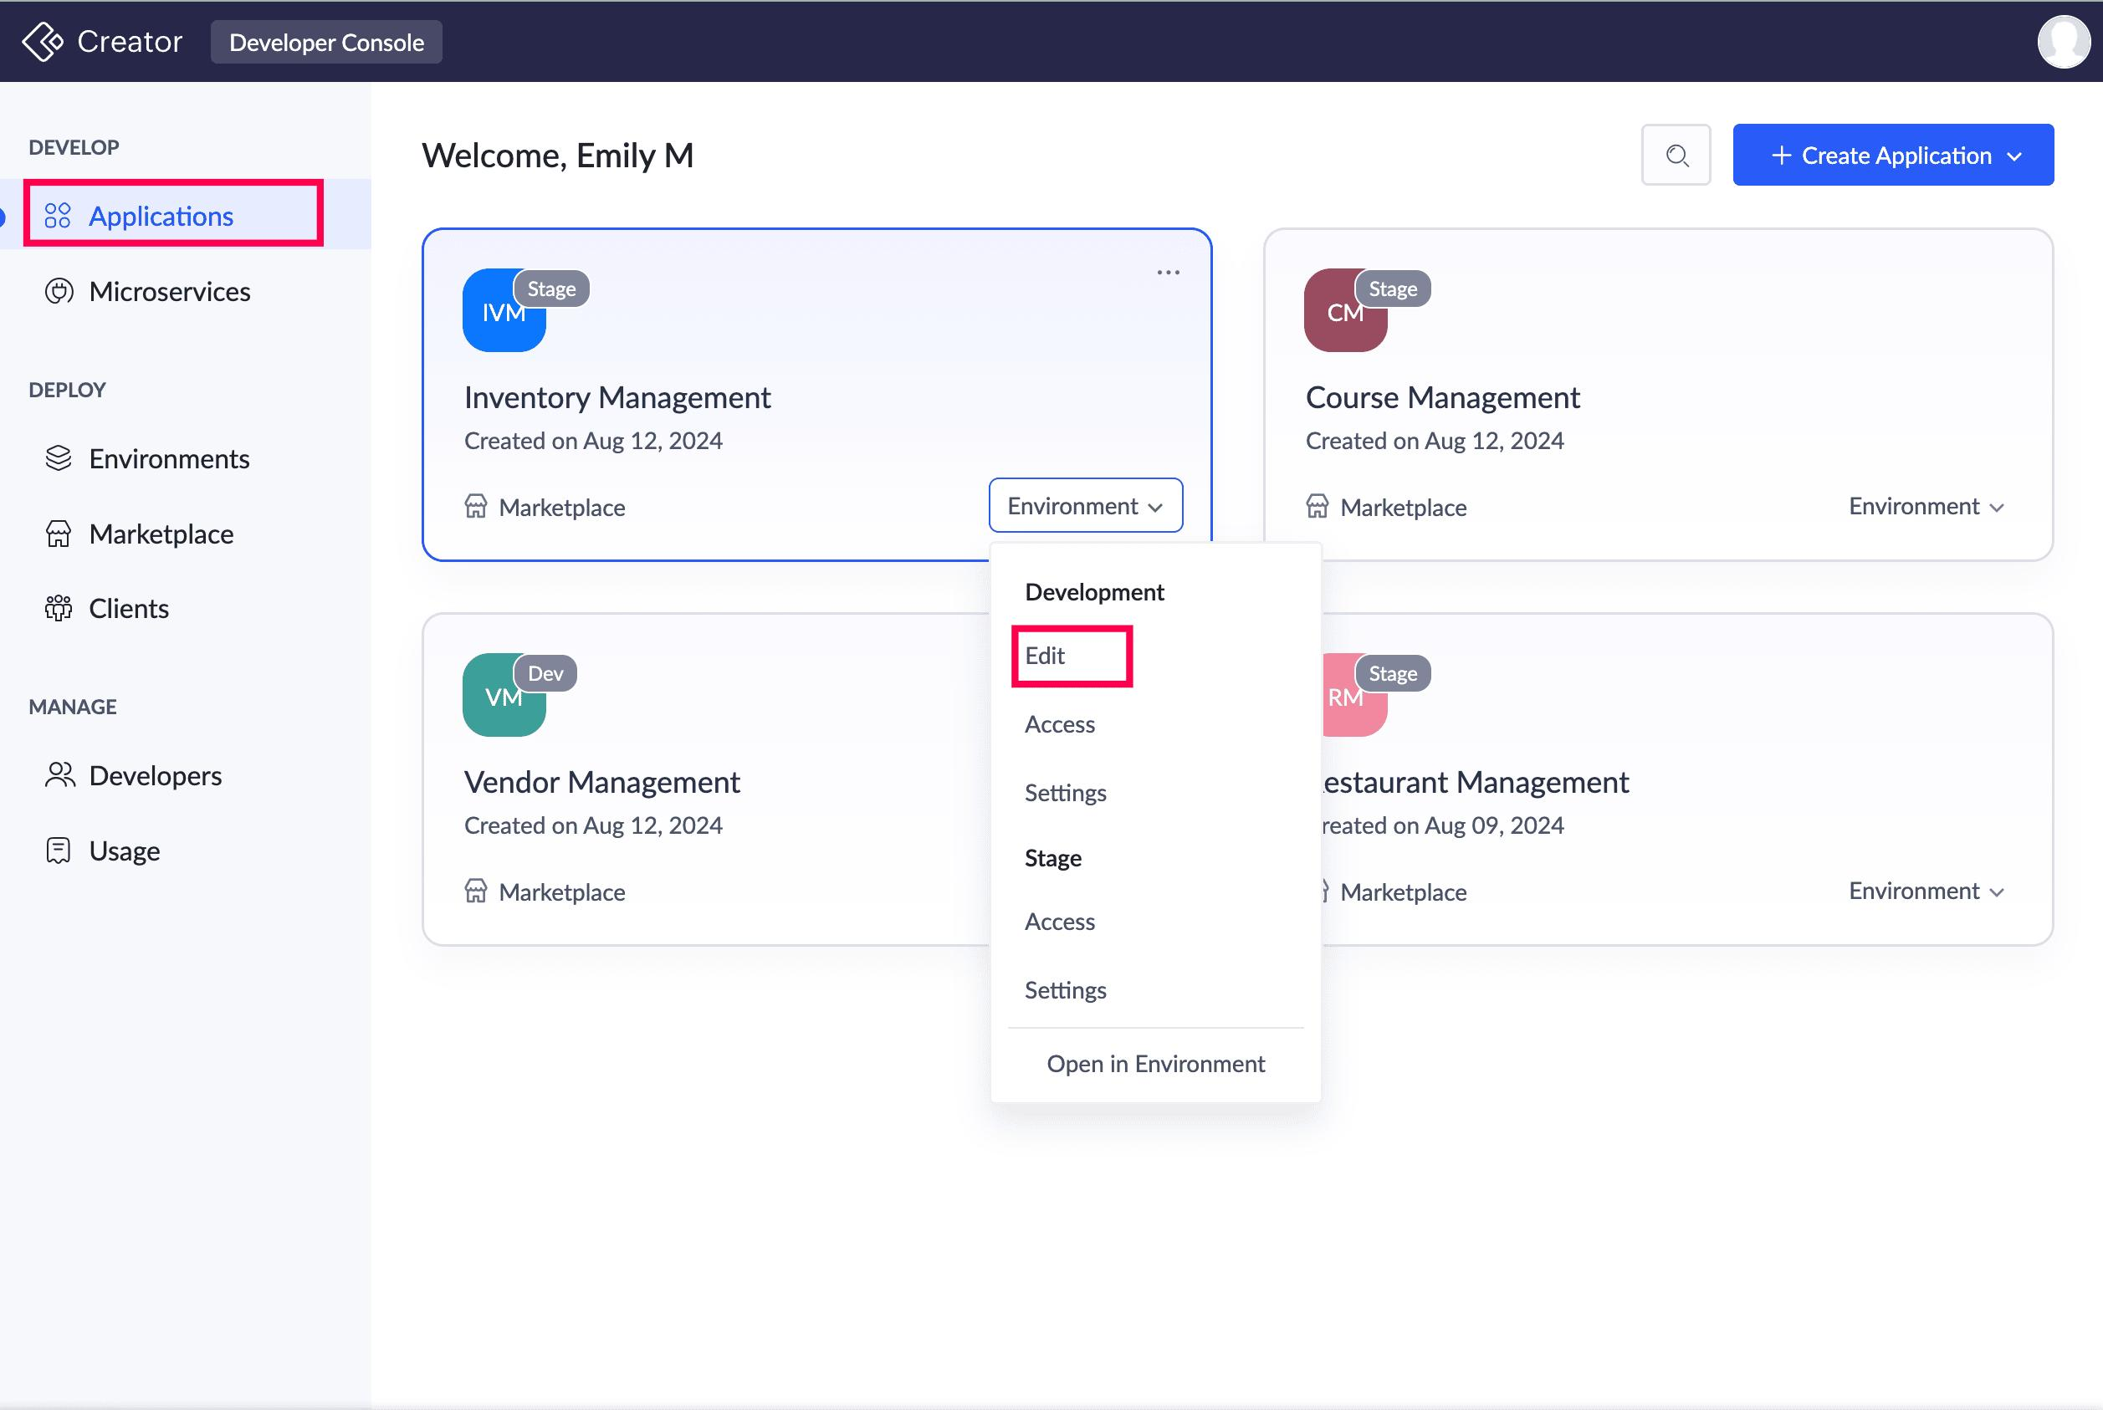
Zoho Creator follows a cloud-based architecture that allows users to develop, deploy, and manage applications from a single platform. The interface is simple and organized, making application development easier through drag-and-drop tools and built-in automation.
The platform architecture consists of the following major components:
- Applications – Collection of forms, reports, pages, and workflows.
- Forms – Used to collect and store data.
- Reports – Display and manage stored records.
- Pages – Create customized user interfaces.
- Workflows – Automate business processes using Deluge scripts.
- Dashboards – Visualize data using charts and widgets.
- Database – Stores application data securely.
- Users & Permissions – Control user access and security.
(Paste Platform Architecture Diagram Here)

Develop
The Develop module is used to design and build applications. Developers can create forms, reports, pages, workflows, functions, and automation using drag-and-drop tools and Deluge scripting.
(Paste Screenshot – Develop Module Here)

Deploy
The Deploy module allows applications to be published and shared with users. Applications can be deployed for web and mobile platforms, making them accessible from anywhere with proper user permissions.
(Paste Screenshot – Deploy Module Here

Manage
The Manage module is used to administer applications by managing users, roles, permissions, environments, backups, and application settings. It helps ensure security and smooth maintenance of the application.
(Paste Screenshot – Manage Module Here)

Result
Thus, a Zoho Creator account was successfully created, and a sample application was developed. Forms, Reports, and Dashboards were explored, and the platform architecture along with the Develop, Deploy, and Manage modules was studied. This experiment provided a clear understanding of the Zoho Creator interface and the fundamentals of low-code application development.

